SELECT from WORLD Tutorial

1. SELECT name, continent, population FROM world

|  |  |  |
| --- | --- | --- |
| **name** | **continent** | **population** |
| Afghanistan | Asia | 25500100 |
| Albania | Europe | 2821977 |
| Algeria | Africa | 38700000 |
| Andorra | Europe | 76098 |
| Angola | Africa | 19183590 |
| Antigua and Barbuda | Caribbean | 86295 |
| Argentina | South America | 42669500 |
| Armenia | Eurasia | 3017400 |
| Australia | Oceania | 23545500 |
| Austria | Europe | 8504850 |
| Azerbaijan | Asia | 9477100 |
| Bahamas | Caribbean | 351461 |
| Bahrain | Asia | 1234571 |
| Bangladesh | Asia | 156557000 |
| Barbados | Caribbean | 285000 |
| Belarus | Europe | 9467000 |
| Belgium | Europe | 11198638 |
| Belize | North America | 349728 |
| Benin | Africa | 9988068 |
| Bhutan | Asia | 749090 |
| Bolivia | South America | 10027254 |
| Bosnia and Herzegovina | Europe | 3791622 |
| Botswana | Africa | 2024904 |
| Brazil | South America | 202794000 |
| Brunei | Asia | 393162 |
| Bulgaria | Europe | 7245677 |
| Burkina Faso | Africa | 17322796 |
| Burundi | Africa | 9420248 |
| Cambodia | Asia | 15184116 |
| Cameroon | Africa | 20386799 |
| Canada | North America | 35427524 |
| Cape Verde | Africa | 491875 |
| Central African Republic | Africa | 4709000 |
| Chad | Africa | 13211000 |
| Chile | South America | 17773000 |
| China | Asia | 1365370000 |
| Colombia | South America | 47662000 |
| Comoros | Africa | 743798 |
| Congo, Democratic Republic of | Africa | 69360000 |
| Congo, Republic of | Africa | 4559000 |
| Costa Rica | North America | 4667096 |
| Côte d'Ivoire | Africa | 23919000 |
| Croatia | Europe | 4290612 |
| Cuba | Caribbean | 11167325 |
| Cyprus | Asia | 865878 |
| Czech Republic | Europe | 10517400 |
| Denmark | Europe | 5634437 |
| Djibouti | Africa | 886000 |
| Dominica | Caribbean | 71293 |
| Dominican Republic | Caribbean | 9445281 |
| Results truncated. Only the first 50 rows have been shown. | | |

1. SELECT name FROM world

WHERE population >= 200000000

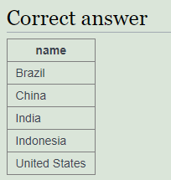

1. select name, gdp/population

from world

where population >= 200000000

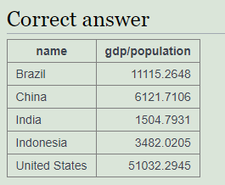

1. select name, population/1000000

from world

where continent = 'South America'

|  |  |
| --- | --- |
| **name** | **population/10..** |
| Argentina | 42.6695 |
| Bolivia | 10.0273 |
| Brazil | 202.7940 |
| Chile | 17.7730 |
| Colombia | 47.6620 |
| Ecuador | 15.7742 |
| Guyana | 0.7849 |
| Paraguay | 6.7834 |
| Peru | 30.4751 |
| Saint Vincent and the Grenadines | 0.1090 |
| Suriname | 0.5342 |
| Uruguay | 3.2863 |
| Venezuela | 28.9461 |

1. select name, population

from world

where name in ('France','Germany','Italy')

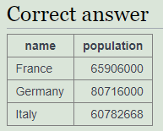

1. select name

from world

where name like 'United%'

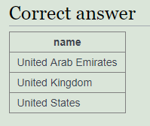

1. select name, population, area

from world

where area > 3000000 or population > 250000000

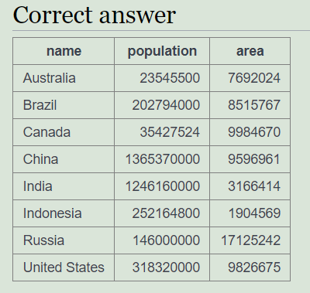

1. SELECT name, population, area FROM world WHERE

(area > 3000000 AND population < 250000000)

OR (population > 250000000 AND area < 3000000)

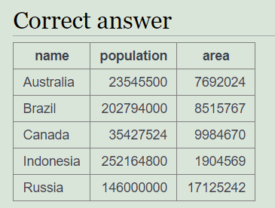

1. select name, ROUND(population/1000000,2), ROUND(gdp/1000000000,2)

from world

where continent = 'South America'

|  |  |  |
| --- | --- | --- |
| **name** | **ROUND(populat..** | **ROUND(gdp/100..** |
| Argentina | 42.67 | 477.03 |
| Bolivia | 10.03 | 27.04 |
| Brazil | 202.79 | 2254.11 |
| Chile | 17.77 | 268.31 |
| Colombia | 47.66 | 369.81 |
| Ecuador | 15.77 | 87.50 |
| Guyana | 0.78 | 2.85 |
| Paraguay | 6.78 | 25.94 |
| Peru | 30.48 | 204.68 |
| Saint Vincent and the Grenadines | 0.11 | 0.69 |
| Suriname | 0.53 | 5.01 |
| Uruguay | 3.29 | 49.92 |
| Venezuela | 28.95 | 382.42 |

1. SELECT name, ROUND(gdp/population, -3) FROM world WHERE gdp > 1000000000000;

|  |  |
| --- | --- |
| **name** | **ROUND(gdp/pop..** |
| Australia | 66000 |
| Brazil | 11000 |
| Canada | 45000 |
| China | 6000 |
| France | 40000 |
| Germany | 42000 |
| India | 2000 |
| Italy | 33000 |
| Japan | 47000 |
| Mexico | 10000 |
| Russia | 14000 |
| South Korea | 22000 |
| Spain | 28000 |
| United Kingdom | 39000 |
| United States | 51000 |

1. select name, capital

from world

where length(capital) = length(name)

|  |  |
| --- | --- |
| **name** | **capital** |
| Algeria | Algiers |
| Angola | Luanda |
| Armenia | Yerevan |
| Botswana | Gaborone |
| Cameroon | Yaoundé |
| Canada | Ottowa |
| Djibouti | Djibouti |
| Egypt | Cairo |
| Estonia | Tallinn |
| Fiji | Suva |
| Gambia | Banjul |
| Georgia | Tbilisi |
| Ghana | Accra |
| Greece | Athens |
| Luxembourg | Luxembourg |
| Mauritania | Nouakchott |
| Peru | Lima |
| Poland | Warsaw |
| Russia | Moscow |
| Rwanda | Kigali |
| San Marino | San Marino |
| Singapore | Singapore |
| Taiwan | Taipei |
| Turkey | Ankara |
| Zambia | Lusaka |

1. SELECT name, capital

FROM world

where LEFT(name,1) = LEFT(capital,1)

and name <> capital

|  |  |
| --- | --- |
| **name** | **capital** |
| Algeria | Algiers |
| Andorra | Andorra la Vella |
| Barbados | Bridgetown |
| Belize | Belmopan |
| Brazil | Brasília |
| Brunei | Bandar Seri Begawan |
| Burundi | Bujumbura |
| Guatemala | Guatemala City |
| Guyana | Georgetown |
| Kuwait | Kuwait City |
| Maldives | Malé |
| Marshall Islands | Majuro |
| Mexico | Mexico City |
| Monaco | Monaco-Ville |
| Mozambique | Maputo |
| Niger | Niamey |
| Panama | Panama City |
| Papua New Guinea | Port Moresby |
| Sao Tomé and Príncipe | São Tomé |
| South Korea | Seoul |
| Sri Lanka | Sri Jayawardenepura Kotte |
| Sweden | Stockholm |
| Taiwan | Taipei |
| Tunisia | Tunis |

1. SELECT name

FROM world

WHERE (name LIKE '%a%' )

and (name LIKE '%e%' )

and (name LIKE '%i%' )

and (name LIKE '%o%' )

and (name LIKE '%u%' )

and name NOT LIKE '% %'

